C121 Readings & Assignments: Week 6

Week 6 Reading
Complete reading all Week 6 lectures early in the week.

Week 6 Assignments Overview
Assignment Summary: | Due Date
Assignment 1: Discussion | Monday, May 11, 2009
Assignment 2: Master Project Part 11: Project Collation and Review | Tuesday, May 12, 2009 to Wednesday, May 13, 2009
Remember that all assignment details can be found on the assignment pages located throughout the week. Go to those specific pages for direction on how to complete each individual assignment.

Week 6 Overview
Congratulations, you have finished five weeks of the course, and it's time to start winding up the assignments and final projects and modify their contents based on the feedback that you got from the other students of the class.
This week we'll focus on revising the master project assignments based on that feedback, collating them, and resubmitting them as a character and object design document for a game.

Learning Outcomes:
Create an object and character design document

Summarizing Character and Object Design
In the last five weeks we've discussed:
- Basic elements and principles of design and type
- Character model sheets
- Emotions
- Gestures
- Character environments
- Motion and movement of objects and characters

During the weeks you learned all the above-mentioned concepts. Remember these are not to be considered separately and individually, but should be combined and used synergistically to create any design - character or object.

Elements and Principles of Design and Type
Points, lines (of varying lengths, widths, curvatures, etc), shapes and form (geometric or organic), color, and texture are the various elements of design. These can help to create art compositions such as the background and objects in an animated scene and the clothes and overall appearance of characters in a story to have the desired effect.
The principles of design such as balance (symmetry or asymmetry), space, movement of the eye, pattern, emphasis, contrast, and unity affect the design elements and can help to enhance designs and compositions.
In addition to graphical illustrations, typography affects the overall ambience and mood of the game by defining the style and design of written text in the game.

Character Design and Model Sheets
Next you learned about the basics of character design and the elements such as species, race, age, culture, past, emotions, profession, and dress that define a character. Each of these elements affects the appearance and behavior of the character.
By incorporating the effects of these elements and the basics of character design, you created different types of Model Sheets - rotation, close-up, and action - of the characters to bring out their personality on paper.
While designing characters the attributes that affect the personality and design of a character include (but are not limited to):

- Age
- Gender
- Weight
- Lifestyle

Emotions and Gestures
Emotions justify the actions and motives of a person, and their appropriate depiction is therefore an important part of character design. You learned how different facial features such as eyebrows, eyes, nose, cheeks, mouth, and teeth individually or in various combinations help express different emotions.
In addition to emotions you learned that gestures define the body language of a character and facilitate the communication process. Gestures can be expressed by using the head, limbs, pelvis, and the backbone.
While studying gestures you started creating a gesture sketchbook, recording all the gestures that you come across in your day-to-day life. This gesture sketchbook will help you study the different movements of the body to communicate the unspoken messages of living beings. An important use of gestures is in communicating the messages and body language of animals because this is the only way, apart from growls and screeches, that humans can understand the intent of the animals.

Cartoons
The next step after character sketches and model sheets was cartoons and humorous drawings. After gaining knowledge of the basics of character drawings including proportions, emotions and model sheets, you moved onto the exaggerated and surreal world of cartoons.
In cartoons you learned how to create a cartoon object or character by retaining its identity, specifying its proportion and shape, and defining its expression.

Character Types
Then we moved on to specific types of game characters: naturalistic (such as Lara Croft and Max Payne), anthropomorphic (such as Shrek and Flubber), antagonist (such as Lord Voldermort), and protagonist (such as Harry Potter and Alice). You learned about their individual personas, purpose of their design, and the method in which you can create them.

Developing the personalities of characters in an interactive media such as games is important because the audience tends to relate to the characters as an extension of itself and builds up expectations from such character types. For the same reason it's also important to consider the audience expectations while implementing the character designs. If a player expects to see a macho superhero like Superman beat up the bad guy but gets gentle looking Aladdin instead, he probably won't like playing the game.

While a successful character design coupled with good gameplay can bring a game into the top-5 category, a poor character design can dismantle it like a house of cards.

After you create rough and fair sketches of characters for your story and draw out their personalities through model sheets, you can collate all these documents to create a character design document for a particular character. Similarly you can create character and object design documents for all objects and characters in a story - for games or for the broadcast media.

A character and object design document can help you bridge the gap between a story concept and a storyboard.
Environments:

In Week 4 we discussed the various aspects of creating a realistic environment for our characters to interact with. We revisited the concepts of perspective; and we discussed aspects of Depth, Foreground, Middle Ground and Background. We found that overlapping objects created a strong feeling of depth. We also saw how the various depths of our characters and objects affect the timing of our animation sequences.

Animation
After creating static character designs, you add life to the characters by introducing motion and movement to create animations. To create good and believable animations a careful study of real life motion is essential.

In Week 5 we discussed the various factors that affect motion such as mass, gravity, weight, balance, speed, and friction. It's not that these factors are mandatory to create good animations, but animations that incorporate these factors tend to be more believable and life-like. These factors provide a guideline that you can follow while creating animations.

Animation is an important medium by which you can communicate a story through pictures and illustrations. It has an edge over regular movies, which have human characters, in a way that you can show happenings, events, and effects that may not be possible in regular movies. To create these happenings, events, and effects you can forego some of the factors affecting motion, which are nothing but a guideline to assist the creation of motion as it happens in the real world. For example you can exclude the effect of gravity in designing an alien in outer space. To depict a bulky plastic toy such as Mr. Potato head you can forego the follow-through effect of his bulging fat as plastic does not follow through like loose skin.

Under character animation you learned about two-legged and four-legged character movements such as walk, run, and jump.

Learning animation involves an extensive effort in observing and understanding real life movements. The replication of these movements in whole or in part helps you create believable animations.

Design Tips
Based on the lectures discussed in the past five weeks and the general practices observed by industry professionals, following are a few design tips that can guide you in character and object design.
(These are not rules, but general suggestions that may help you in character and object creation.)

- Viewers like variety. Within a story try to include different types of characters - those that have strikingly different and interesting personalities. Remember your characters are competing with numerous characters of various games and stories on the market, so they need to attract audiences and bind them to the story.
- Do not make excessive use of stereotypes; rather, make your characters unique. Stereotypes are easily identifiable, but they are also far too generic. One or two stereotypical characters in a story are good because they make the story easier to understand, but an excess of stereotypes can make a game very dull. You can avoid monotony and bring uniqueness and interest into a game by including a few non-stereotypical and new characters.
- Do not imitate existing characters. When you design characters, make them unique so that they stand out in the crowd. They should not be influenced or cloned from existing characters - whether or not they are popular.
- Make a believable character. Create characters that the audience can relate to; which they feel may come to life. Create the character such that the player develops an emotional attachment to it and starts caring for the character.
  - Behavioral flaws enhance the depth of a personality. Experiment with attributes such as stammering, limping, and other flaws that we encounter in our day-to-day lives. Remember, nobody is perfect, so why should your character be? However ensure that the attribute does not appear to the audience as an error in the character design. It should live up to its intent.
  - Create an intelligent character. It's nice to have a character grow and develop in intelligence and skills as the story progresses. After all in real life everyone learns from experience too!
  - Don't make an infallible character. A believable character is one who has its own set of weaknesses and vulnerabilities. You can use this as a factor that excites the character or makes it react strongly.
- Get into the character's shoes. While creating the character personality it's a good practice to start living in the character's shoes and think like the character. A notebook dedicated to the character and its details will prove to be very useful. Think of different situations from daily life that you come across and then think how the character will react to it as opposed to the way you react and why. Note down such details throughout the development phase. This will help to bring out the true personality of the character to the entire development team.
- Characters have attitude, make sure it shows. Model sheets and character sketches (other than reference images) should convey the attitude of the characters. Their body language and the manner in which they carry themselves should be clear from looking at static picture or illustration of the character.
- Hold back the information; let the audience discover. Don't disclose every part of the personality of a character in its appearance, a few and subtle surprises will add spice to a story. Capture the audience's attention by assisting them in deducing and arriving at conclusions about game characters as a story progresses.
- Everything is not meant to be told, or shown. It's not necessary to disclose every aspect of the character to the audience. Most of the character related information is useful for the people behind the scenes such as the animator, 3D modeler, and voice over artist.
- Should decision-making events be included in games to reveal character personality? As compared to a linear story, in a game you have less scope for revealing the personality of a character through decision-making, because it's not the character but the player who actually makes the decisions. Nevertheless it's important to have such character related information because it helps in creating the character. Such decisions are brought to the fore and define the personality of a character either through cut scenes or in multiplayer games where the decision of one player affects the others. Because a character is an extension of the player, the personality of the player is reflected in the actions of the game character. Likewise when a player needs to decide some crucial issues on behalf of the character, the personality and decision-making skills of the player are affected, though at a very micro level. In the long run, such games and characterizations may lead to affecting the players' personalities - in either good or bad ways. It's an issue that needs to be addressed by the farsighted game developers of the next decade.
- Keep it simple. For games, try not to make characters that are complex in design (resulting in heavy files and slower interactivity) and personality (resulting in the player getting too involved in understanding the character more than playing the game). The player is more interested in playing the game quickly and intelligently. Also in some games there's a time constraint, and a slow refresh rate may become irritating.
- Have courage to break the rules. Experiment with design; try going beyond the convention, but don't risk the very existence of the game. Try creating characters or objects that defy gravity or those that look like humans but have different proportions. Have a character that appears very innocent but behaves very craftily. But don't do it if you feel that it'll cause chaotic reactions in the player's mind. Such experiments need to be handled carefully, because the player's attachment to a game can be very fragile.
- Create situations around the character. Everyone, except a robot, interacts with and is affected by the environment around them; so create an environment that relates to the character.
- Include normal movements in animations - such as blinks, effect of wind, effect of inertia, birds or clouds in the sky, rustling of leaves in the wind, and flowing of dress or garment while walking. This adds believability to animations because this is what we are used to seeing in the world around us.
- Do not over/under use anything. Try adding variety to your designs while maintaining their core strength and uniqueness. An overdose of evil looks may appear unrealistic; a subtle tinge of goodness in looks or behavior can add depth to an antagonist's personality.
- Think like the director of a movie. Plan your layouts, compositions, story, characters, movements, and functionality to be the most optimum mix. All characters, objects, and background in an animation should look like a complete picture; nothing should appear jarring or out of sync with the core concept. If the character design is complex and heavy, try using a simple background. If the camera view of a character or object is consistently going to be from a distant perspective, you needn't spend too much time in refining the intricacies of the physical appearance.

Design Differences
The basic character and object designs can vary based on the following criteria:
- Media
- Objective
Media
The type of media that you are creating characters or objects for affects their design. This is because of the limitations and strengths of the different communication media. Let's look at each of them briefly.
- Print media: Print media graphics have a high-resolution rendering starting from 300 dpi. Also a reader or the audience has ample time to look at and study each graphic and, any minute flaw or inconsistency is sure to be detected. Therefore all print media graphics tend to have an extensive level of detail. A drawback of the print media is that it's the least interactive and does not provide scope for the layering of information that in other media prompts the audience to explore. To compensate for that, print media graphics can be accompanied by explanatory text that may answer anticipated questions of the audience. Since there are no animations or series of pictures that are created in one piece, it's easy and less time consuming to make any post production alterations. It can be used to display static:
  - 2D or 3D graphics of objects or characters
  - Cartoon strips
  - Supporting graphic for story
  - Advertising
- Video and other broadcast media: The resolution of all broadcast media is generally 768 x 576 pixels, and the rendering resolution is more than that of game output but less than that of print. Because of this the visual quality of broadcast media is in between that of print and games. The graphics created for this media can serve two purposes, special effects in real-time productions or a complete unit as in animated movies. While the character and object designs for special effects need to be intricately designed so that they merge in with the real world characters, those of animated movies may or may not be very detailed (it all depends upon the producer's requirements). For example the animation and character design of Stuart Little in the movie Stuart Little is very detailed and complex to match the real-time movements of the actors enacting the roles of the Little family members. In contrast the characters of the movie Shrek are designed with an objective to create a fantasy story and therefore make no attempt to exactly imitate real life actors. Both the movies are examples of successful animations.

- Games: A popular form of interactive media is games. Here the player plays games that require her to solve a problem, fight an enemy, finish a task in limited time, etc. Because of this the sole focus is not to tell a story to the player but to make her do something and see its results instantly. Consequently complex graphics are generally avoided as their file sizes tend to slow down the interactivity that is the core strength of the game. The resolution of games can vary from 320 x 240 pixels onwards up to 1024 x 768 pixels depending on the hardware specifications. A control guideline, suggested by a few industry experts, states that graphics should only take up half the game's size. Consequently the character and object designs for games tend to have least complexity and maximum functionality. Also as no real-time storytelling is happening in a game, some breakpoints in the form of cut scenes (non interactive animation sequences) are introduced to build up a story.
Objective
Objective of the design refers to the purpose for which it will be used. The linked table lists some differences in character and object designs based on their objectives.
Click on each entertainment type to view its objectives, examples, and character and object design specifications.
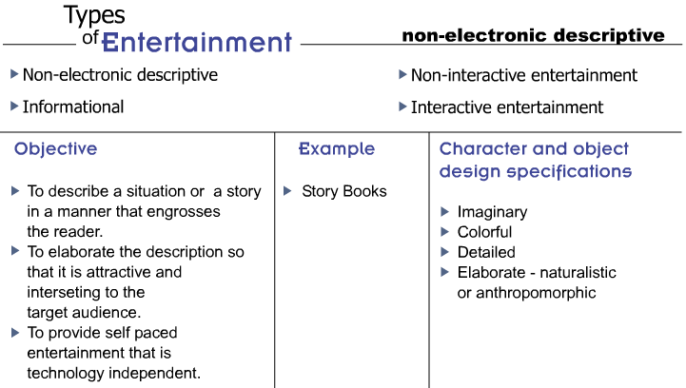
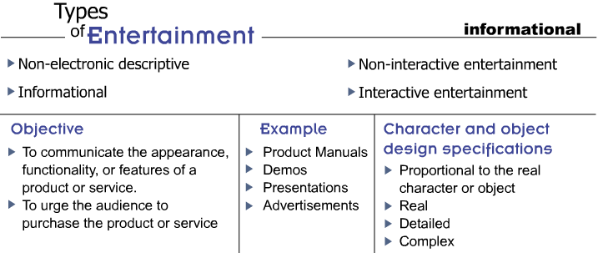
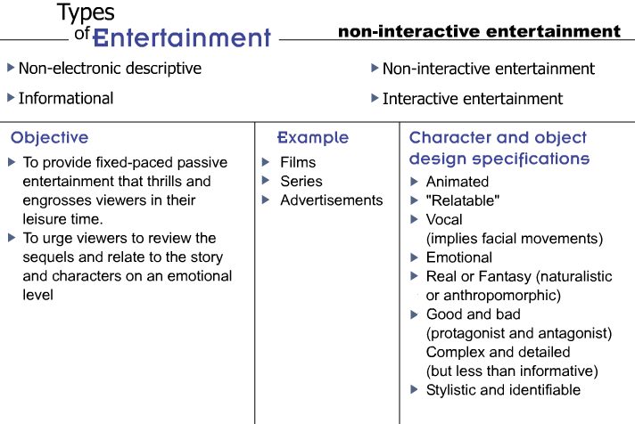
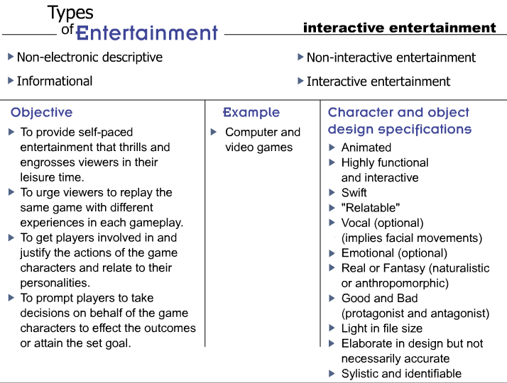

Concluding the Design Process
To create well-designed characters, objects, and compositions, it's important to subject them to a pre-and post-design analysis to check whether the concept and output are in sync and in the correct direction. It's not necessary for the designs to retain their original structure by the time you are through with the entire creation process. In most cases the final output rarely matches the initial sketches of the designer. Nevertheless the pre- and post- analysis is necessary as it helps you understand how the character design evolved from start to end.
You needn't worry if the final design is very different from the initial concept; just ensure that the macro level vision is consistent. All the characters and objects designed for a specific story should blend and gel with the story world and the core concept.

Conclusion
The field of character and object animation has vast and indefinable horizons. The lectures in this course have attempted to bring out and discuss all elements that go into creating character and object designs and the factors facilitating their transition from static images into movable characters. From here you need to build on the abilities such as creating good character designs, model sheets, and animation sequences, and establish a strong foothold in this ever-expanding world of design and animation.
Using these lectures and their content as reference, you can create a checklist for your reference to identify all the elements that you can incorporate in any character or object design. This will help you not only for this series of courses but also in your professional life when you actually start working in this field.
Remember, the best formula for success in any field of art is dedicated and persistent practice. Practice will not only help the muscles of your hand and arms to open up to create smooth sketches but will also synchronize the thought process of the brain with the movement of the hands. The more you practice, the better you'll get.
Good luck with your practice!

Assignment 1: Discussion
By Monday, May 11, 2009, respond to the discussion questions assigned to you by the facilitator. Submit your responses to the appropriate Discussion Area.
Post your responses to the comments of other students to the appropriate Discussion Area as early in the week as possible.
Assignment 1 Grading Criteria: | Maximum Points
Responded meaningfully to all questions | 4
Arrived at well formed conclusions | 4
Justified all statements and conclusions with the help of references or examples | 4
Participated in class discussions and gave constructive feedback and comments | 4
Total: | 16
For assistance with any problems you may have when completing this assignment—OR—to offer your assistance to classmates, please use the Problems and Solutions Discussion area located through the left side navigation link.
Please respond to at least ONE of these questions and respond to at least TWO of your classmates to receive full credit. Include an inciting question in your posts if you can.

DQ 1 - Based on your character and object design experience of the last five weeks, discuss the best practices that you followed to improve your artwork.

DQ 2 - Character and object animation as discussed in this course is just the tip of the iceberg. There are numerous sub-areas such as game character design, facial animation, and motion capture (to name a few) that are still to be explored. Discuss the existence of such specialized fields and their popularity. Which of these areas fascinates you and why? What efforts do you propose to increase your knowledge in your to increase your knowledge in your preferred area? Discuss the links and resources that can help your fellow students in networking with industry professionals.
Assignment 2: Master Project Part 9: Project Collation and Review

Over the last five weeks you developed various segments and sections of the game concept that was described in Week 1 lectures. You created art compositions, character sketches, model sheets, animation sequences, reference images, and environments for characters and objects. It's time now to look back at the work that you've created, review it, and improve upon the creations.
By Tuesday, May 12, 2009, review all the character sketches, model sheets, 2D models, and animation sequences that you've submitted in the previous weeks and identify the areas that you have improved in.
Share your knowledge from the course with other students by posting your comments to the appropriate Discussion Area.

Your master project involved the creation of a character and object design document for the proposed game project. In addition you were required to create a gesture sketchbook across the weeks, recording and sketching all the gestures that you come across in day-to-day life along with their descriptions.
By Wednesday, May 13, 2009, scan and post all the observation sketches (at least 30) to the Week 6 Dropbox.

Also compile your assignments titled "Master Project" submitted during the course into a complete character design document in a manner that they can be used to create the storyboard of a game. If required, modify the submissions of each of the assignments based on the feedback that you got from the facilitator and your classmates. Post the final documents to the appropriate Discussion Area.
Assignment 2 Grading Criteria: | Maximum Points
Posted at least 30 gestures used in day-to-day life (4 points each) | 120
Each gesture matched its description and communicated the message specified in the description | 4
Shared at least five lessons with other students | 4
Adhered to the principles of design and type in all creations | 4
Ensured the following in 2 model sheet designs:  - Consistency  - Proportion | 16
Brought out the personality of the respective characters and objects in the model sheets | 4
Incorporated the factors affecting movement in all animation sequences | 4
Ensured the relation and consistency of all the designs to the initial game concept | 4
Participated in class discussions and gave constructive feedback and comments | 4
Justified all comments | 4
Actively participated in the Problems and Solutions discussion forum | 4
Total: | 172
For assistance with any problems you may have when completing this assignment—OR—to offer your assistance to classmates, please use the Problems and Solutions Discussion area located through the left side navigation link.

Day of reckoning! Please post all required materials in an organized PDF for easy downloading and viewing. Please label and organize in the form of a nice neat digital portfolio. To clarify, you are posting two PDF's - one is of at least 30 gestures/sketches from life that you've been hopefully working on each week. The second is an organized culmination of all the work you've done in this class. You may make corrections and improvements to those pieces before posting based on notes you received from classmates or myself, if you have time.
Read the grading criteria and be sure you've satisfied each graded element. This exercise is good practice for when you are collecting and organizing your work for your portfolio.
Cheers!

